Introduction
Tokojaya Lao Assurance Co., Ltd (Toko Assurance) has been in the insurance business in Laos for over ten years and is seen as a well-respected firm that has played an important role in shaping the local insurance industry.

Why Insure with Toko?
  Dedicated professional |   Speedy claim settlement with in-house specialized expertise |   Financial security with our panel of reinsurers
  Local focus |   Multi – lingual advisors | 24 hour hotline for emergency

Our networks

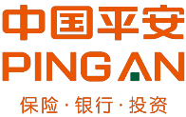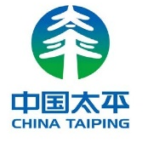


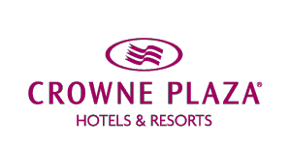   AND MORE …

In April 2018, Forte Insurance (Cambodia) Plc (Forte) acquired a majority 95% controlling stake in Toko Assurance Co., Ltd.

Forte commands a 46.8% market share in Cambodia. In December 2016, Forte was rated A+ with outlook accorded as Stable in terms of claim-paying abilities on a national scale by Global Credit Rating Co.

Forte has received numerous accolades over the years. In 2017, acclaimed banking and finance organization Global Banking & Finance Review recognized Forte with two in-country awards:
- Best General Insurance Company
- Best Insurance Customer Service Company

Synergies
Laos has one of the lowest penetrations of insurance in the world and according to WHO around 65% of the medical expenditure is out of pocket.
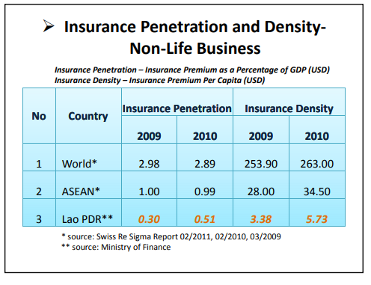
The per capita income of Laotians is growing rapidly but is still quite low. 80% of the population is employed in the agricultural sector where the incomes tend to fluctuate a lot. It is therefore imperative to increase insurance penetration in order to reduce the out of pocket expenditures as much as possible.

- Lao telecom has more than 50% of the market share in Laos. Since the Lao government is a majority stake holder, the welfare of people will be paramount to the company.
- A major problem faced by mobile operators in developing countries is the high customer churn. Customers buy multiple sims and use whichever operator gives them what they need at that specific time.
- Forte has experience in providing insurance at ~ 1$ per month and can use Lao Telecoms mobile platform and customer base to deliver microinsurance to the bottom of the pyramid in Laos.
- The partnership will result not only in including the financially unserved population of Laos, but will increase customer stickiness for Lao telecom while adding an additional revenue stream. For Forte (Toko Assurance) it adds a distribution channel using which it can reach the remotest corners of the country.

Indicative Product, and customer journey
Option A  Loyalty Product | ARPU Levels | Product | Cover
Option A  Loyalty Product | ARPU > 25000 | Life | 1000$
Option A  Loyalty Product | ARPU > 35000 | Hospitalization | 10$ per night
Option A  Loyalty Product | ARPU > 40000 | Hospitalization + life | 1500$ for life and 10$ per night
Option B  Paid Product | Product | End User Price | Cover
Option B  Paid Product | Life | 2 Cents per day | 1000$
Option B  Paid Product | Hospitalization Basic | 2 cents per day | 10$ per night
Option B  Paid Product | Hospitalization Premium | 4 Cents per day | 20$ per night
Option B  Paid Product | Hospitalization Family Basic | 5 cents per day | 10$ for a family of 4
Option B  Paid Product | Hospitalization Family Premium | 10 cents per day | 20$ for a family of 4

*Prices and products are indicative and will finally depend on the number of customers and other actuarial factors.

Customer Journey – Option A (Loyalty Product)
Lao Telecom gives details to Toko about customers who qualify for free insurance
Message is sent to customers to tell them about their insurance
Toko Agent calls customer to educate them about insurance
When customer wants to claim, they call Toko Call center
Toko agent asks for documents to be sent via whatsapp/ facebook messenger
Claim is processed within 48 hours and claim amount is sent via – Mobile money/ online transfer

Customer Journey - Option B (Paid Product)
Once customer confirms, they receive summary of their policy via sms
Lao Telecom segments the customer as per ARPU and gives list of numbers to Toko
Toko Call centre agents call customer and educate them about insurance
If customer agrees Toko agent registers the customer in the system
Registration triggers a message to customer asking them to confirm via ussd code
Around 2-4 cents start getting deducted from customer every day
When customer wants to claim/ Deregister, they call Toko Call- center
Toko agent asks for documents to be sent via whatsapp/ facebook messenger
Claim is processed within 48 hours and claim amount is sent via – Mobile money/ online transfer

